**CHAPTER - I**

**INTRODUCTION**

**1.1 Background**

A departmental store management system is a program that enables users to easily add items, edits items, display all items, search item and delete items. This system is developed using the general need required to the user while managing goods in store. [1]

User requires to access all the facilities of the program; add, edit, display, delete any data related to store. The program provides the important information lists which include the rate, quantity, name and their serial code etc. A new function will be added into this system i.e. searching goods by their name for each complete information.

**1.2 Statements of problem**

The similar project based on departmental store management system that we have gone through, have certain problems such as keeping records in ledger, editing of pre-existing records, insufficiency search engines (search by recorded name, serial code and rate.), absence of password system.

**1.3 Objectives**

The main objective of this project is to reduce the manual work for managing the store details: name, serial code, rate & quantity, through computerized system.

**1.4 Scope & Limitation**

The scope of this project is that it can be implemented in various Departmental Store. The project will be designed to meet the growing needs of the user. It will be very easy, reliable and effective for quick adding/storing, editing, searching and listing out the details of goods.

The current system in use is a paper-based system (i.e. ledger system). It is too slow and cannot provide updated lists of products in store. Taking the different scopes of our project in consideration there still are many limitations to our project. Few of the limitation are listed below:

1. Our project is still unable to perform any online operations.
2. It is time consuming for those who are not well known with the program.
3. Poor security and protection.

**CHAPTER - II**

**LITERATURE REVIEW**

Undeniable computerized Departmental Store Management System is a general trend, this provides the name, serial code, rate, quantity etc. to the user. It provides easy access to search and list out the goods details with user friendly. In previous project, GUI was not used, which are not the reliable, effective and organized way of keeping records in this modern era. So, a lot of computerized systems are introduced for well management system. [1]

For the reference of this project, we first looked up in Wikipedia for the concept of management system. Then we searched up in the websites for the previous development and designing interfaces used in the actual scenario. We looked up in the website mentioned in the reference below for the designing idea when the writer of the web page has described about the basic algorithm of the program. [2]

**CHAPTER - III**

**METHODOLOGY**

**3.1 Background**

For the completion of the entire project, various data and resources were used and will be in use. Various source codes were used during the project so primarily we had the counseling with the related teachers and our seniors. The ideas and logic are being discussed within our team members, other friends, teachers and supervisor.

However, the internet itself is leading us providing fruitful and crucial ideas. Various books, websites, senior's reports related to C and C++ programming and other database have been our secondary source of the data.

**3.2 Block Model**

Exit

Edit Item

Display items

Delete item

Login

Customer list

Vendor list

User

Balance

Calculate Bill

Add Item

Exit

Search Item

Fig:4.1

* 1. **Algorithm**

Step 1: Start

Step 2: Display login page

Step 3: Enter the Username and Password

If match go to step 4

Else go to step 2

Step 4: Choice Display

* If “Calculate Bill” is clicked go to step 5
* If “Add Items” is clicked go to step 6
* If “Edit Items” is clicked go to step 7
* If “Display Items” is clicked go to step 8
* If “Search Item” is clicked go to step 9
* If “Delete Item” is clicked go to step 10
* If “Customer list” is clicked go to step 11
* If “Vendor list” is clicked go to step 12
* If “Financial” is clicked go to step 13
* If “Add User” is clicked go to step 14
* If “Delete User” is clicked go to step 15
* If “Expiration Date” is clicked go to step 16
* If “Exit” is clicked go to step 17

Step 5: If “Add to cart” is clicked then enter item information.

If “Buy” is clicked then enter customer information then go to step 4

Step 6: Clicked desired category and enter item information then go to step 4

Step 7: Clicked desired category and enter code and edit the item information and go to step 4

Step 8: Display all item and go to step 4

Step 9: If “Name” is clicked then enter name and display detail of that item and go to step 4

If “Code” is clicked then enter item code and display that item detail and go to step 4

Step 10: Enter item name and if found then delete that item and go to step 4

Step 11: Display customer information and go to step 4

Step 12: Display vendor information and go to step 4

Step 13: Display Financial Report and go to step 4

Step 14: Enter New Username, password and user details and go to step 4

Step 15: Enter Existing User detail/Account.

If Admin is deleted then, Enter new Admin in step 14

If User is deleted then go to step 4

Step 16: Display expired item details

Step 17: Exit the program.

**3.4 Flowchart**

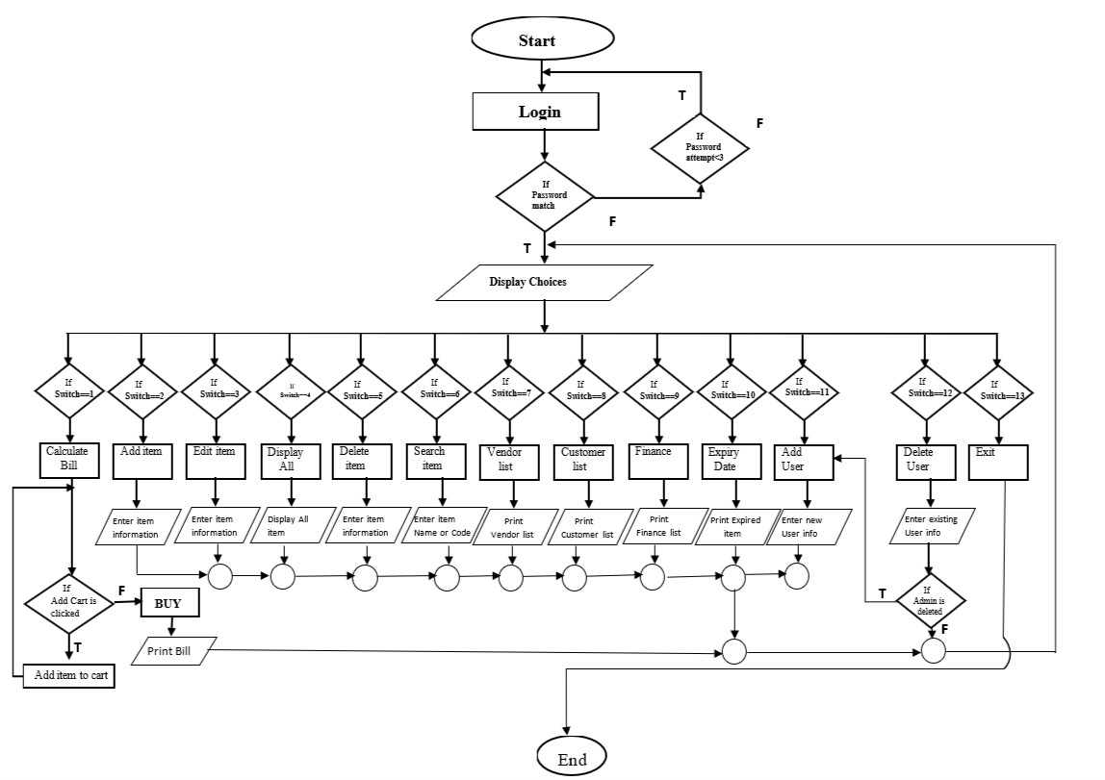

**3.5 Tools and Platform**

As we all are familiar with the C/C++ programming languages, we find suitable to use Turbo-C. Features of C/C++ like data encapsulation, class concept, file handling, file pointers, graphics and so on has been used. With these features, our project has been executable and record the store’s details & enable graphical interface to some extent.

**CHAPTER - IV**

**RESULT AND DISCUSSION**

**4.1 Overview**

The result we obtained during our study is quite satisfying. This system is able to add and edit other product information. The system is capable of searching the products info, and updating that information. The access to the Admin is provided through the unique user ID and the password. Besides, this system provides unique ID to all the employees/User as well. The system has the features of categorizing the goods which helps to access the goods database easily.

**4.2 Analysis of Result**

There were some problems and limitations seen during the rest phase. Lack of data security is seen in the system. As far as the limitation goes, the system is not capable to add more category and which is the major drawback of this system.

**4.3 Task Completed**

We have done lot of progress in our project while developing it. The 2/3 portion of this project have been completed. Throughout this project we done following progress and which are as follows:

* Calculation of bill
* Add/ Edit of items
* Searching, deletion and displaying of existing item
* Vendor, Customer, Financial detail
* User and admin login

Some of the footage of our project are as below.

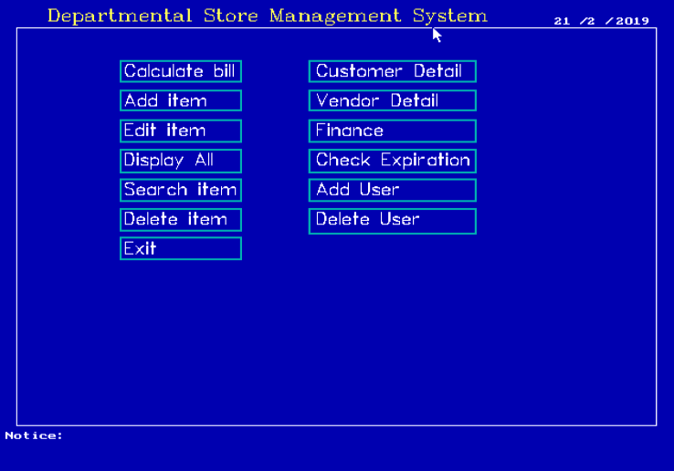

**Homepage**

This is the home/front page of our project displaying the major function such as calculate bill, Add item, edit item, delete item and so on.

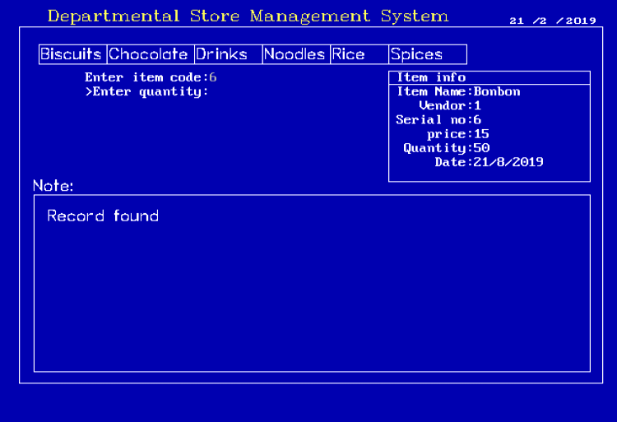

**Add Item to Cart**

Above picture is of Add item where one can add item in the given categories, first by entering its specific code of the item.

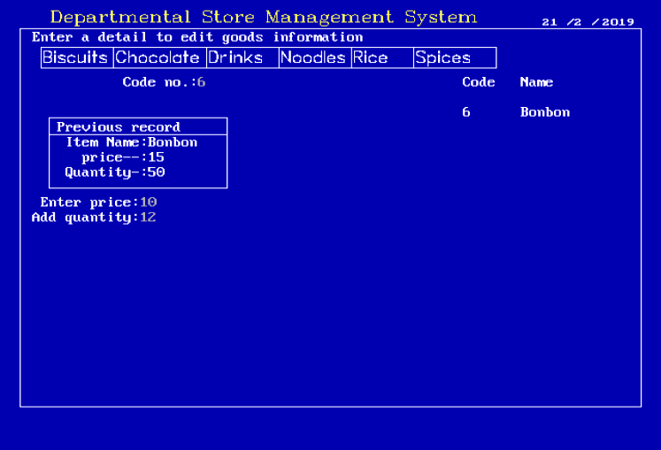

**Editing**

Above picture is of Edit item where one can edit the details of item such as price and quantity of item but first one should enter its specific code of the item.

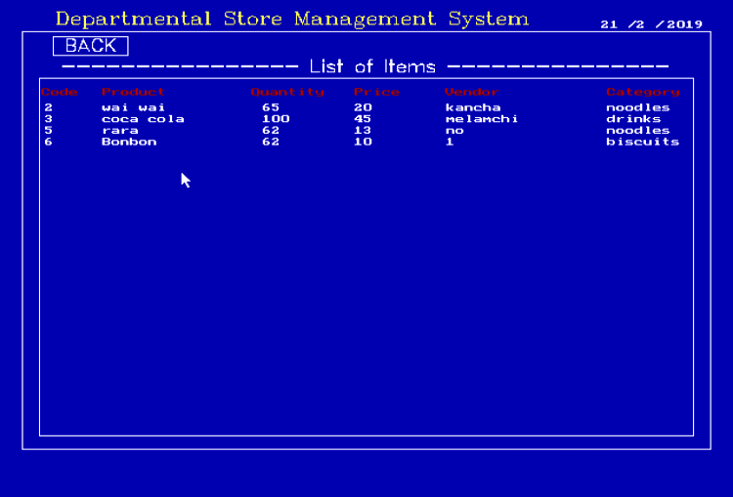

**Display**

Above picture is of Display where User/ Admin can view the entire detail of the existing data such as: quantity, price, vendor detail and so on of the system.

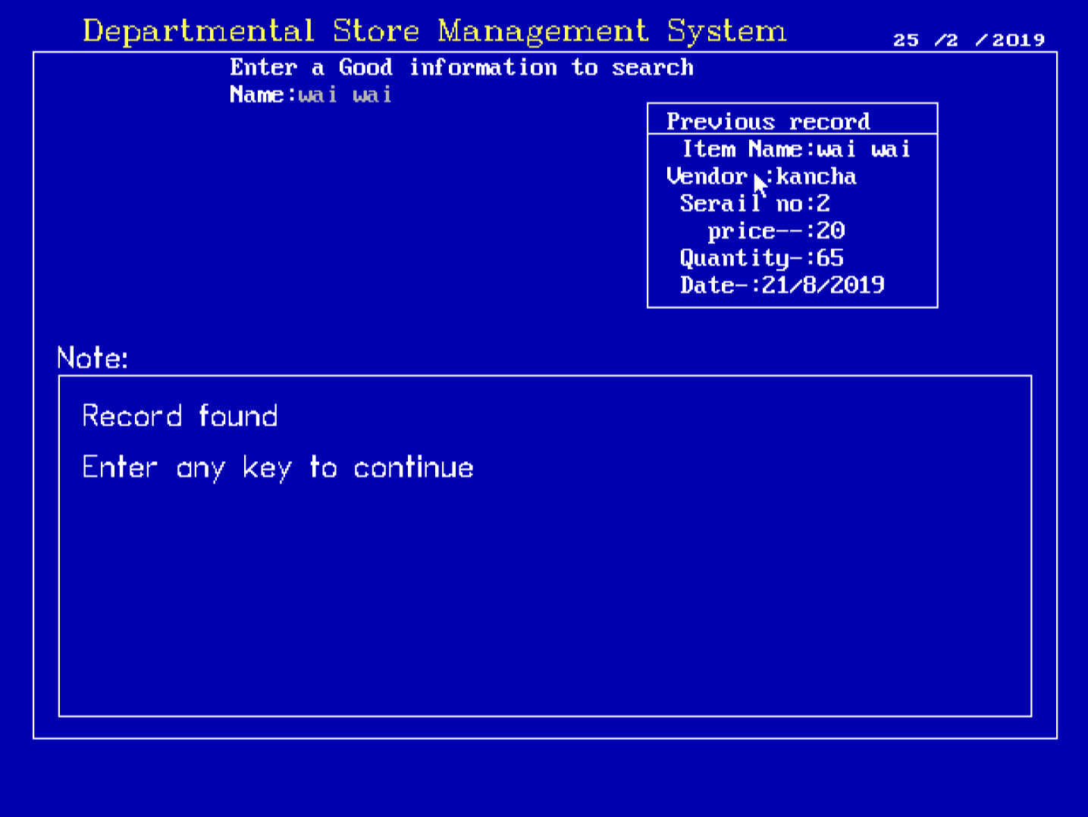

**Search**

Above picture is of Search where User/ Admin can search the detail of the existing data of an item such as: quantity, price, vendor detail and so on of the system.

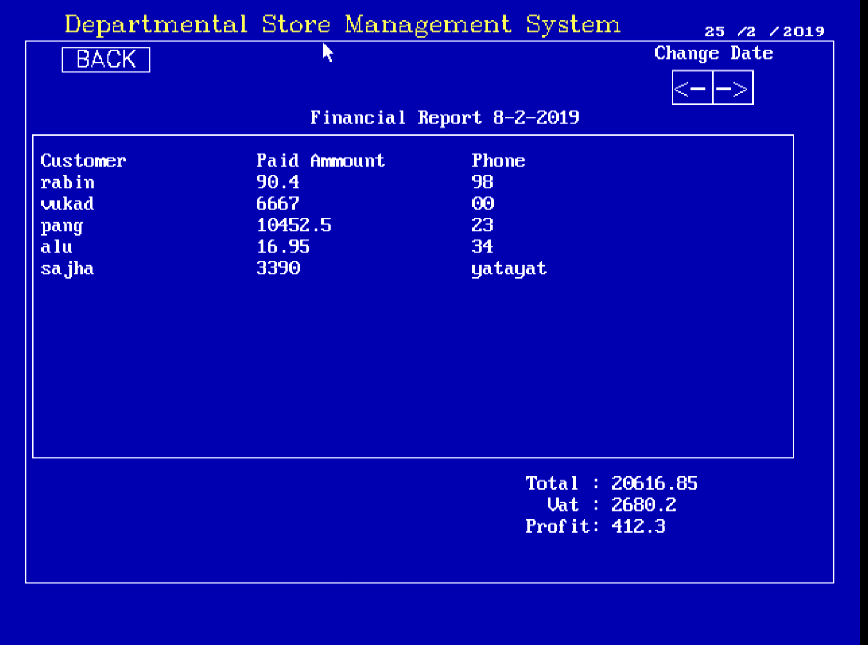

**Financial Report**

Above picture is of Financial Report where User/ Admin view the detail financial transaction of the

Store.

**4.4 Remaining Tasks**

As 1/3 of the project is still on progress and we still have to include the following features which are as follows:

* Notice
* Time
* Expiration Date

**CHAPTER-V**

**CONCLUSIONS AND RECOMMENDATION**

**5.1 Conclusion**

The project Departmental Store Management System is for computerizing the working in stores. It is a great improvement over the manual system. The computerization of the system has speed up the process. In the current system, the font office managing is very slow. The system was thoroughly checked and tested with dummy data and thus is found to be very reliable. The software takes care of all the requirements of a store and is capable to provide easy and effective storage of information related to employees/User, customer and vendor.

The system also provides the facility of backups as per the requirement.

**CHAPTER-VI**

**REFERENCES**

1. <https://www.codewithc.com/category/cpp-tutorial/> [11/18/2018]
2. <https://www.programiz.com/c-programming/examples> [12/18/2018]

